Experiment 1: Create a Kanban Board using Jira/Trello

Aim
To create and simulate a Kanban workflow using Jira or Trello by organizing tasks into different stages such as To Do, In Progress, and Done, and to understand how Kanban helps in visualizing and managing project activities.

Procedure
- Open Jira or Trello and create a new account or log in to an existing account.
- Create a new project/board and name it, for example, “Software Development Kanban Board.”
- Select the Kanban Board template.
- Create the following workflow columns:
  - To Do
  - In Progress
  - Testing/Review
  - Done
- Create task cards for the project. For example:
  - Requirement Analysis
  - Design User Interface
  - Develop Login Module
  - Develop Database
  - Test Application
  - Deploy Application
- Initially place all pending tasks in the To Do column.
- Assign tasks to team members and add descriptions, priorities, due dates, or labels where required.
- Start the workflow by moving a task from To Do to In Progress when work begins.
- Move the task to Testing/Review after development is completed.
- After successful testing, move the task to Done.
- Continue moving the task cards through the workflow until all tasks are completed.
- Observe the board to monitor task progress and identify pending or delayed tasks.

Output:
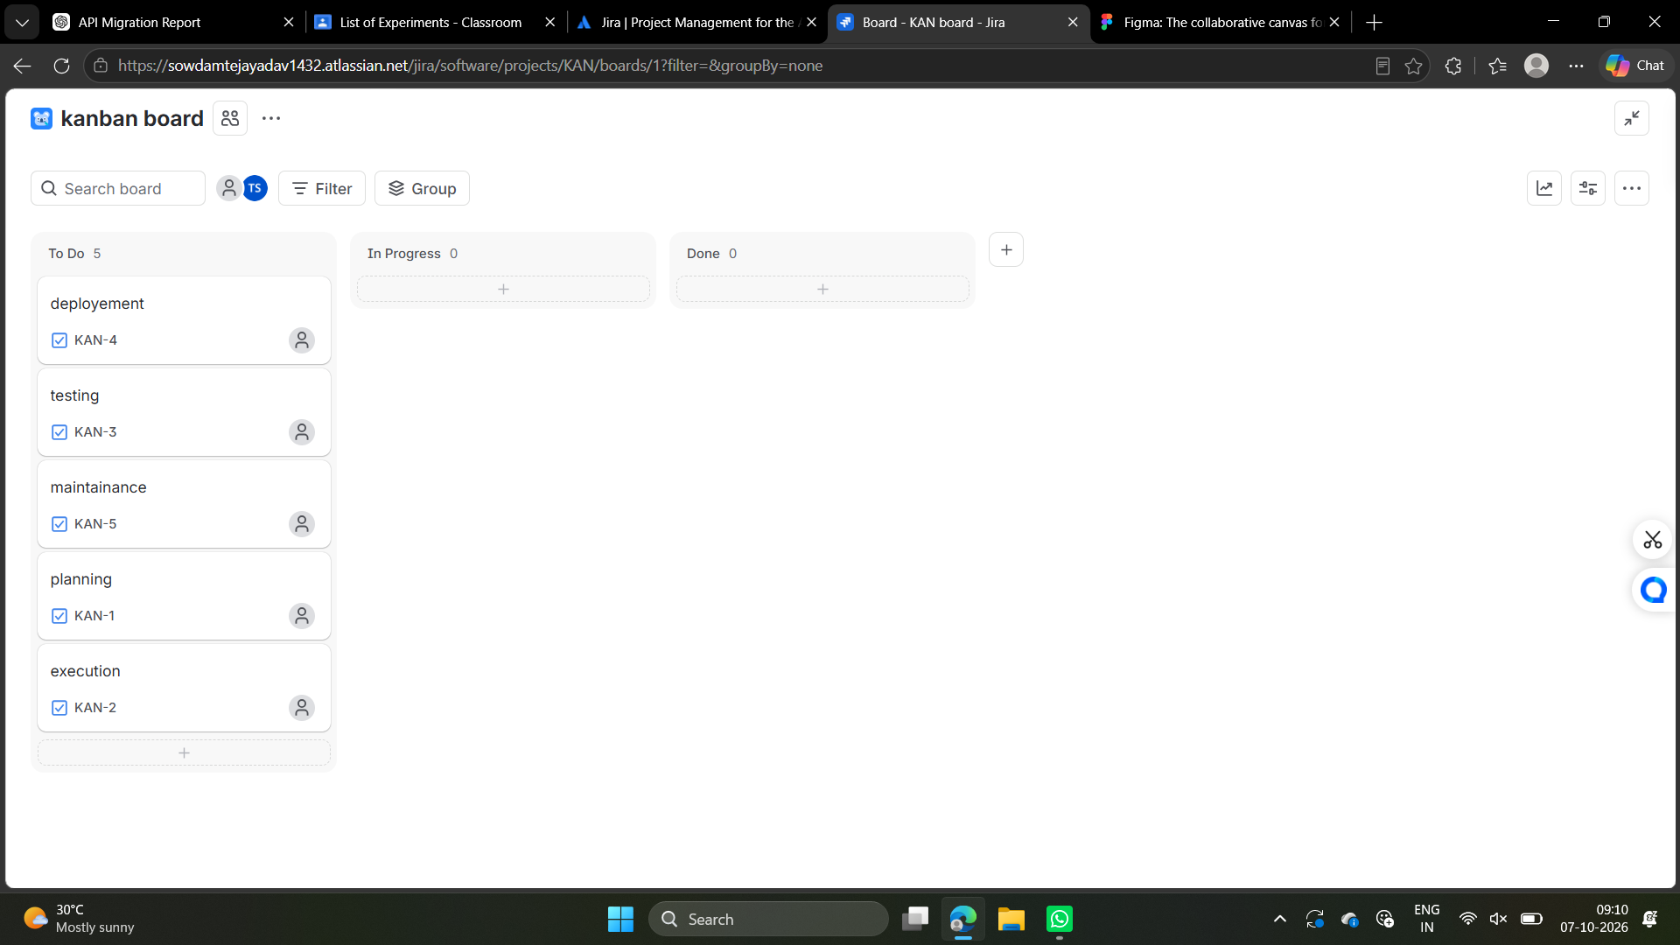
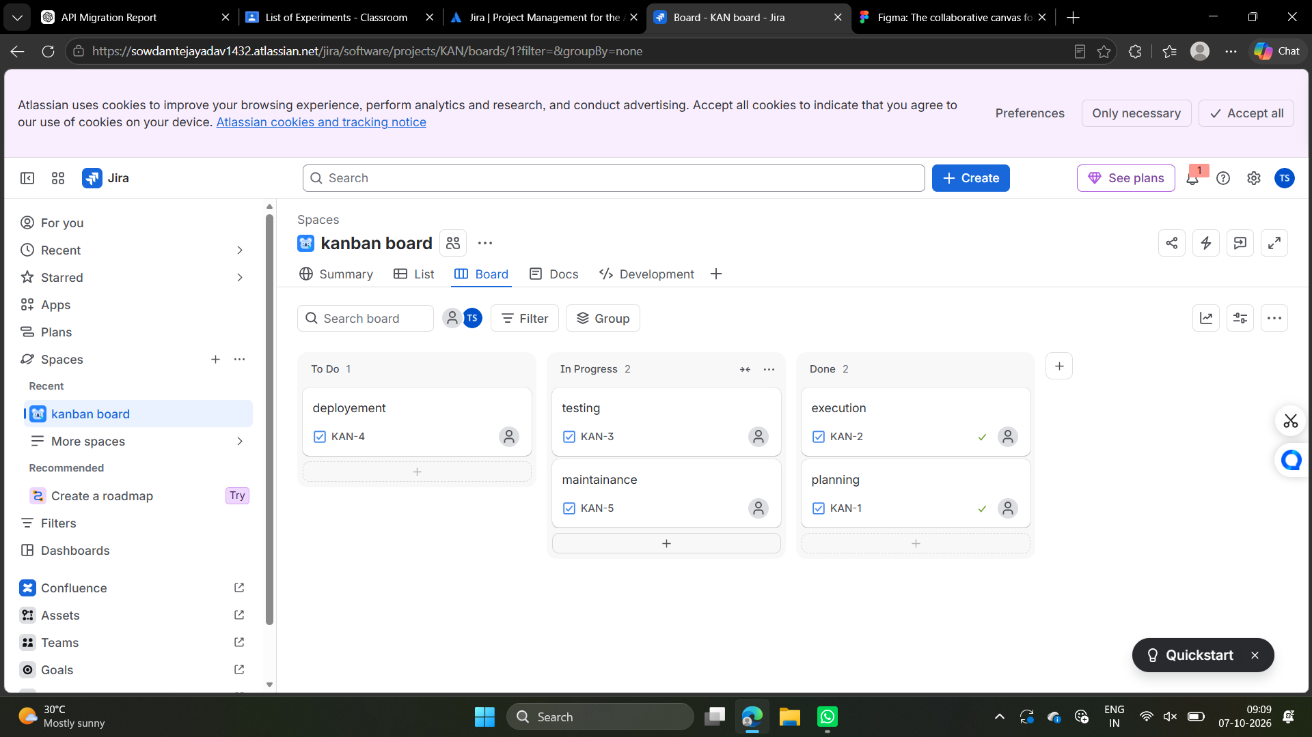

Result
A Kanban Board was successfully created and simulated using Jira/Trello. Tasks were organized into different workflow stages and moved from To Do → In Progress → Testing/Review → Done.

